Insert School Logo

Semester Two Examination 2019

Question/Answer Booklet

MATHEMATICS
METHODS UNITS 3 & 4

Section Two:
Calculator-assumed

Student Name: _____________________________________

Teacher’s Name: _____________________________________

Time allowed for this section
Reading time before commencing work: ten minutes
Working time for paper: one hundred minutes

Material required/recommended for this section

To be provided by the supervisor
This Question/Answer booklet
Formula Sheet (retained from Section One)

To be provided by the candidate
Standard items: pens(blue/black preferred), pencils(including coloured), sharpener, correction tape/fluid, erasers, ruler, highlighters

Special Items: drawing instruments, templates, notes on two unfolded sheets of A4 paper, and up to three calculators approved for use in the WACE examinations.

Important note to candidates
No other items may be taken into the examination room. It is your responsibility to ensure that you do not have any unauthorised notes or other items of a non-personal nature in the examination room. If you have any unauthorised material with you, hand it to the supervisor before reading any further.

Structure of this paper

 | Number of questions available | Number of questions to be attempted | Working time (minutes) | Marks available | Percentage of exam
Section One  Calculator—free | 9 | 9 | 50 | 52 | 35
Section Two  Calculator—assumed | 15 | 15 | 100 | 98 | 65
 |  |  |  |  | 100

Instructions to candidates

- The rules for the conduct of Western Australian external examinations are detailed in the Year 12 Information Handbook 2019. Sitting this examination implies that you agree to abide by these rules.

- Answer the questions according to the following instructions.

Section Two: Write answers in this Question/Answer Booklet. Answer all questions.

Show all your working clearly. Your working should be in sufficient detail to allow your
answers to be checked readily and for marks to be awarded for reasoning. Incorrect
answers given without supporting reasoning cannot be allocated any marks. For any
question or part question worth more than two marks, valid working or justification is required to receive full marks. If you repeat an answer to any question, ensure that you cancel the answer you do not wish to have marked.

It is recommended that you do not use pencil, except in diagrams.

- You must be careful to confine your responses to the specific questions asked and to follow any instructions that are specific to a particular question.

- Spare pages are included at the end of this booklet. They can be used for planning your responses and/or as additional space if required to continue an answer.
- Planning: If you use the spare pages for planning, indicate this clearly at the top of the page.
- Continuing an answer: If you need to use the space to continue an answer, indicate in the original answer space where the answer is continued, i.e. give the page number. Fill in the number of the question that you are continuing to answer at the top of the page.

- The Formula Sheet is not handed in with your Question/Answer Booklet.

Section Two: Calculator–Assumed 98 marks

This section has fifteen (15) questions. Attempt all questions. Write your answers in the spaces provided.

Spare pages are included at the end of this booklet. They can be used for planning your responses and/or as additional space if required to continue an answer.

- Planning: If you use the spare pages for planning, indicate this clearly at the top of the page.
- Continuing an answer: If you need to use the space to continue an answer, indicate in the
original answer space where the answer is continued, i.e. give the page number. Fill in the
number of the question(s) that you are continuing to answer at the top of the page.

Working time: 100 minutes

Question 10 (5 marks)

Cameron conducted a survey on the preference of dark chocolate with 72% cacao over milk chocolate with as little as 10% cacao. Her findings are as follows.
Using a sample of 500 people, the z% confidence limits for the proportion of people preferring dark chocolate are 0.2278 and 0.2922.
(a) Show that the number of people in the sample of 500 who preferred dark chocolate is 130.
(3 marks)

(b) Determine z and hence find the confidence level to the nearest 5%. (2 marks)

Question 11 (10 marks)

The Bank of Prosperity in Western Australia has established that 63% of all Credit Card accounts are paid in full by the due date.
Let X be the random variable “an account is paid in full by the due date”.

(a) Determine the probability that in a sample of 20 Credit Card holders:

(i) at least 14 people pay their account in full. (1 mark)

(ii) all 20 people pay their accounts in full, if at least 14 do. (2 marks)

(b) How many people would need to be selected if the probability of having at least one customer paying their account in full by the due date is at least 0.95?
(3 marks)

(c) For a sample of 300 Credit Card holders determine the mean and standard deviation.
(2 marks)

(d) How many Credit Card holders should be checked to establish whether they pay their account in full by the due date to an accuracy of 5% at a level of confidence
of 90%? (2 marks)

Question 12 (3 marks)

A company determines that its marginal revenue per hundred litres of a certain product is 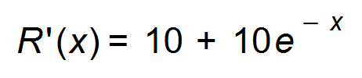(in $) if x litres are produced. Its marginal cost per hundred of production is 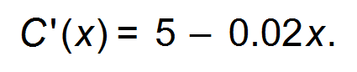 Determine the profit earned on sales between 500 and 1000 litres.
(3 marks)

Question 13 (7 marks)

A darts player aims repeatedly for the bull’s-eye. He counts it a success if his dart hits the bull’s-eye. It may be assumed that on each throw the probability of success is 0.25, independently of all other throws.

(a) Find the probability that, in a series of throws,

(i) the first success occurs on the fourth throw. (1 mark)

(ii) the first success occurs between the fourth and sixth throws inclusive.
(2 marks)

(b) (i) Explain why a throw can be considered to be a Bernoulli trial. (2 marks)

(ii) State the expected value and standard deviation of this trial. (2 marks)

Question 14 (7 marks)

The amount of petrol sold at a garage every day is modelled by a normal distribution with a mean of μ litres and standard deviation σ litres. The amount sold, x litres, was recorded each day.
A random sample of 75 days showed the following data summary:
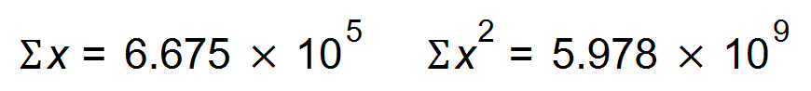

(a) Show that the mean of the sample is 8900 litres. (1 mark)

(b) Show that the standard deviation for the sample of 75 days is 705 litres. (2 marks)

(c) Given that between 7000 and 10 000 litres of petrol is sold on any given day, determine the probability that less than the 8550 litres is sold. (2 marks)

(d) If the amount of petrol sold is less than 2.6 standard deviations from the mean, the garage runs at a loss on that day.
Determine the minimum amount of petrol, to the nearest litre, which needs to be sold for the garage to be profitable. (2 marks)

Question 15 (3 marks)

The velocity, v in m/s, of an object moving in a straight line is measured at time t seconds
for 0 ≤ t ≤ 5.

Data is given below. (3 marks)

t | 0 | 1 | 2 | 3 | 4 | 5
v | 0 | 10 | 15 | 16 | 11 | 4

Using rectangles, find the approximate distance travelled by the object from t = 0 to t = 5.

Question 16 (8 marks)

A talk radio show conducts a survey regarding whether the Australian public would be in favour or against Prince Harry becoming the new Governor General of Australia. They ask the listeners to call in or text their Yes or No response to the question: “Would you like Prince Harry to become the new Governor General of Australia?”

(a) Explain two likely sources of bias in the survey. (2 marks)

(b) Describe a strategy that would eliminate the bias you have identified in (a). (1 mark)

The radio show claimed that from the survey of 300 people who called in, the vote for Prince Harry to be the Governor General would be 15% ± 3%.

(c) What is the margin of error stated in the result? (1 mark)

(d) Determine the point estimate of the population given in the result. (1 mark)

(e) State the level of confidence for this interval. (3 marks)

Question 17 (7 marks)

Two straight roads in the country meet at a station, point S, at an angle of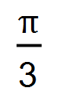radians.
At time t = 0, car A leaves S on one road, and car B is 100km from S on the other road.
Car A travels away from S at a speed of 80 km/h, and Car B travels towards S at a speed of 50km/h.
The distance between the cars at any time t hours is r km.

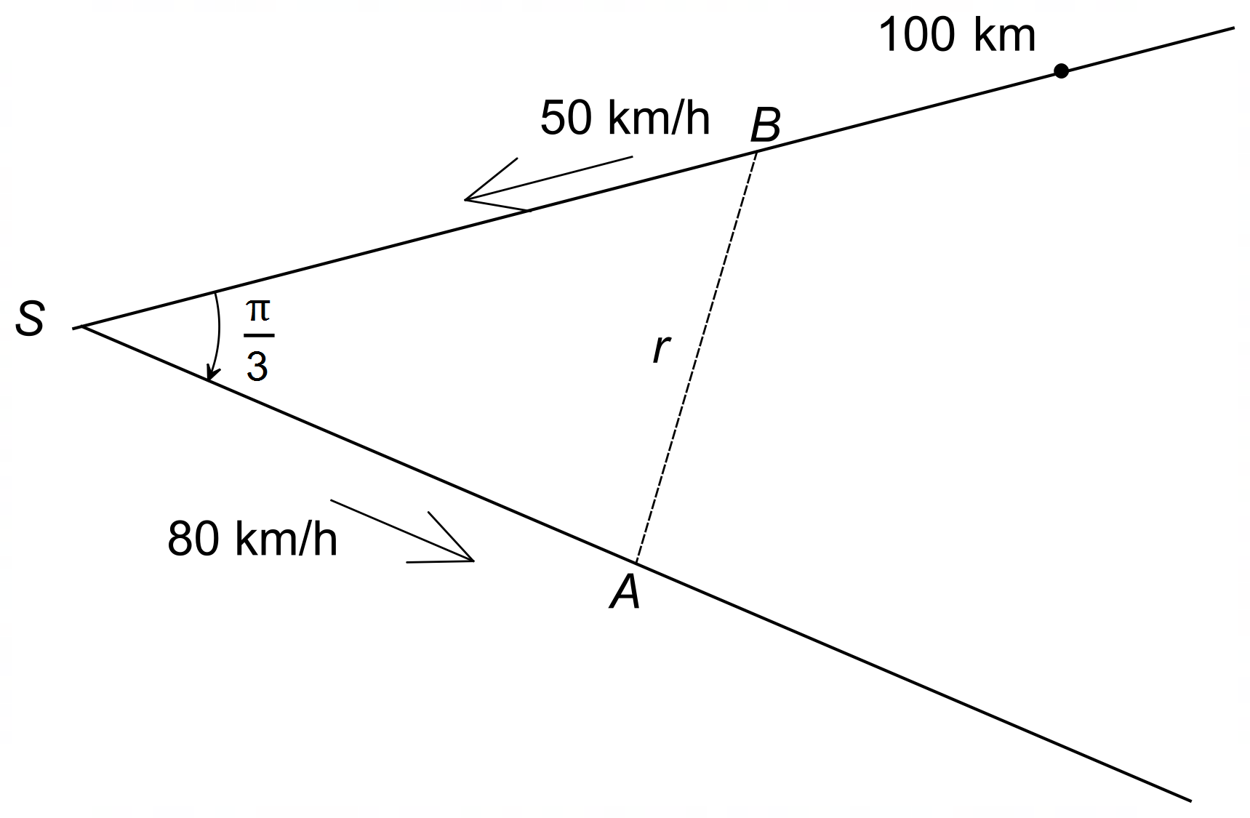

(a) Show that 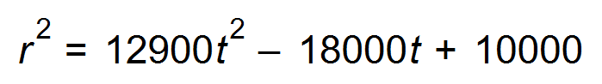. (3 marks)

(b) Use Calculus methods to find the minimum distance between the two cars.
Show that your answer is a minimum.
(Hint: the minimum of r occurs at the same time as the minimum of r².) (4 marks)

Question 18 (9 marks)

Emily decides to cycle to school to save fuel and help the environment. She takes between 25 and 40 minutes to get to school depending on the traffic conditions. Assume this is a uniform probability distribution.

(a) State the probability density function p(x). (1 mark)

(b) What is her mean travelling time? (1 mark)

(c) Determine the probability that she takes less than 30 minutes to get to school. (1 mark)

(d) School starts at 9 am. If Emily leaves home at 8:30 am, determine the probability
that she will be late:

(i) on any given day?
(1 mark)

(ii) on 3 consecutive days in a week from Monday to Friday. (1 mark)

(e) Hannah also decides to ride to school. Her mean time is 26 minutes with a variance of 12.25. Let the random variable H = aX + b where X is the CRV for Emily’s cycle ride and H is the CRV for Hannah’s cycle ride. Determine the values of a and b. (4 marks)

Question 19 (7 marks)

On an island in the Pacific, an environmental event is declared a natural disaster if the damage is estimated to be exceeding $100 000 000. The time (t) in months, between natural disasters is a continuous random variable.
T has a cumulative distribution function F defined by F(t) =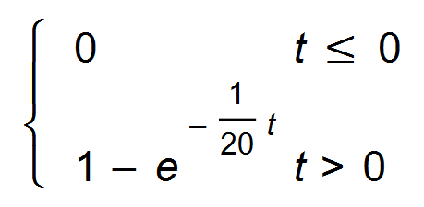

(a) Find the density function f (t). (2 marks)

(b) Determine the probability that after a natural disaster, the next natural disaster will occur within 20 months. (1 mark)

(c) A natural disaster has not occurred for 25 months. What is the probability that a natural disaster will occur in the next 15 months. (2 marks)

(d) Determine the mean time between natural disasters. (1 mark)

(e) The probability of a natural disaster not occurring for q months is 0.096.
Find the value of q. (1 mark)

Question 20 (9 marks)

An electronics company manufactures nanosensors that convey data and information at the nanoscale level. The probability that the nanosensor will fail within x years after it is activated is given by
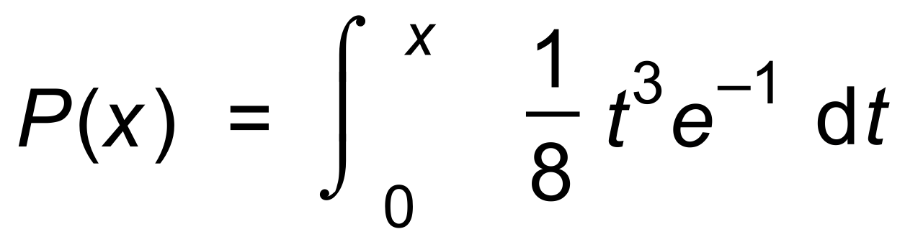

(a) For what value of x is P(x) a probability density function? (2 marks)

(b) At what rate is P(x) increasing 3 years after the manufacture date? (2 marks)

(c) Determine the probability that the component will fail between 1 and 3 years. (2 marks)

(d) Use the incremental formula to estimate the probability of the failure of the
nanosensor on the day exactly three years after its activation date. (3 marks)

Question 21 (8 marks)

A company employs 3000 staff. The yearly income for the staff is normally distributed with 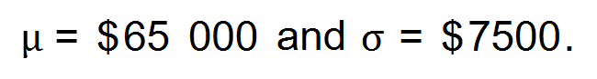

(a) A staff member on a contract earns an amount which is two standard deviations
below the mean. Approximately how many people are contracted to work for the
company? (1 mark)

(b) (i) 8% of the staff are in executive positions. What is the minimum wage of an executive?
(1 mark)

(ii) Three staff members are selected at random. What is the probability that one of them will be an executive? (2 mark)

(c) The company decides to increase the salary of all staff members by 2.5%. Furthermore, everyone will receive a bonus of $250. What is the new mean and standard deviation of the yearly income? (2 marks)

(d) The Finance Department decides to form a committee to organise social events on a Friday evening for their department. A stratified sample of 15 people forms the committee from 80 accountants, 132 administration staff, 104 interns and 50 financial analysts.
How many interns should be on the committee? (2 marks)

Question 22 (5 marks)

Bass and carp are types of fish found in fresh water lakes and dams. A dam contains a number of carp. At a certain time, 10 bass are introduced into the dam. However, they start to eat the carp and the population of carp decreases. The number of carp, N, at a given time t in months, is modelled by the equation 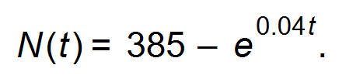
The population of bass, B, increases according to 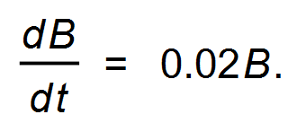
(a) How many carp were in the lake when the bass were introduced? (1 mark)

(b) When will the population of carp be zero? (1 mark)

(c) When is the number of carp equal to the number of bass? (3 marks)

Question 23 (5 marks)

On a particular day 100 donors come in to donate blood. Assume that the blood donors are not related in any way, so that they can be considered independent. The probability that the donor has type-O blood is 0.06, which is constant from donor to donor. Let X = the number of donors that have type-O blood.

(a) For a sample of 100 donors, explain why the sampling distribution of the sample proportion can not be determined. (1 mark)

(b) (i) For a sample of 300 donors describe the sampling distribution and state its parameters.
(3 marks)

(ii) For the sample of 300 donors, find the probability that the sample proportion is greater than 0.01. (1 mark)

Question 24 (5 marks)

(a) Find the equation of the graph f (x) where f (x) = ln (x + a) + b. (2 marks)
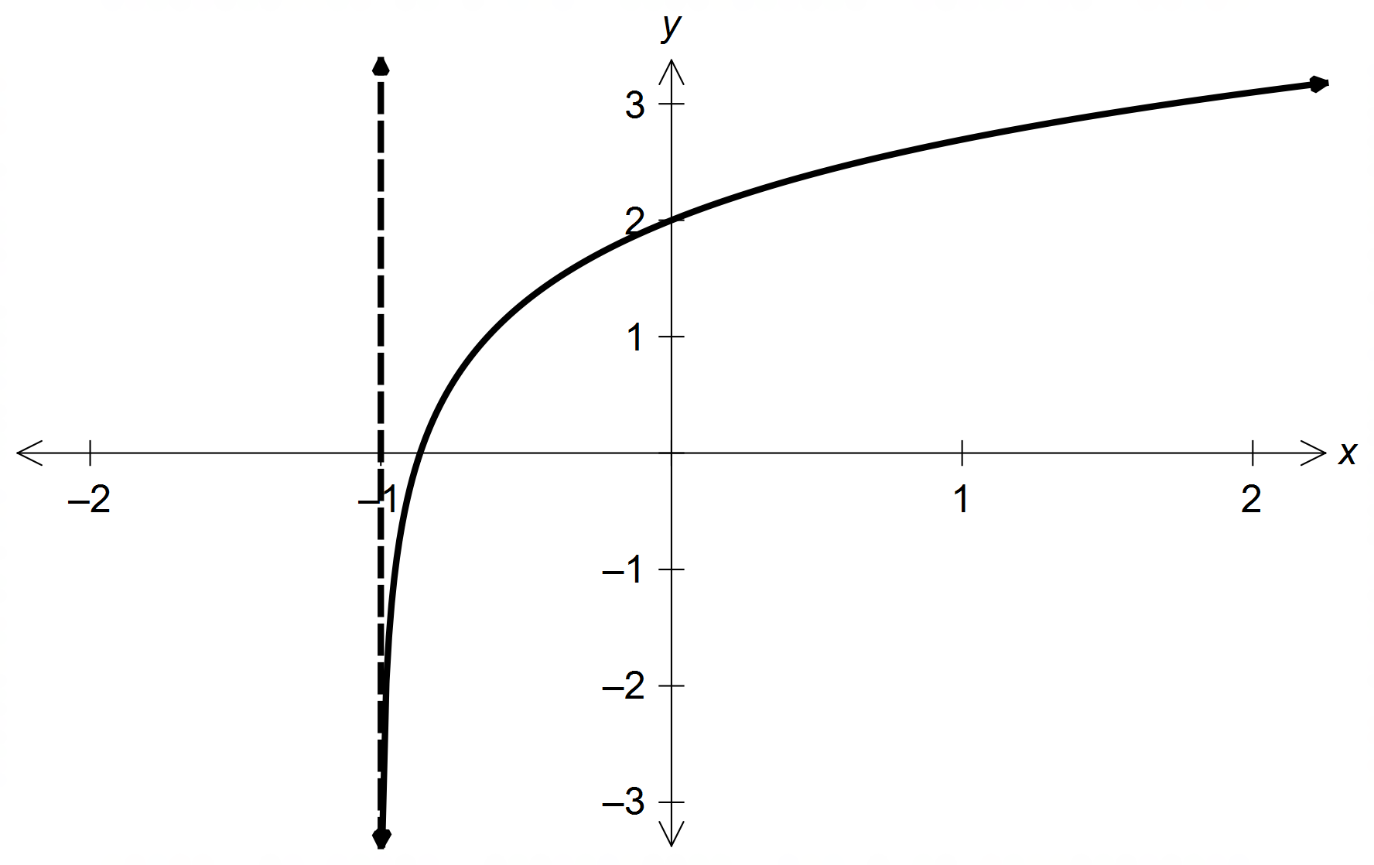

(b) The sensation of loudness of sound L in decibels (dB), is related to the intensity of the sound I by the formula 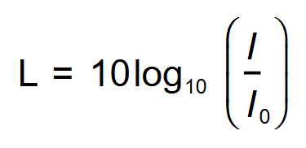 where 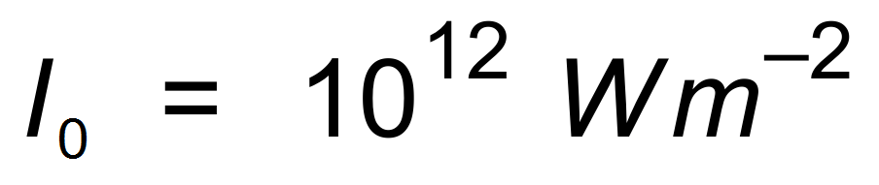 (Watts per m²) is the lowest intensity sound that can be heard by human ears.

(i) A whisper is approximately 10 dB and an ordinary conversation is approximately 60 dB. Calculate and compare the intensities (W/m²) of each sound. (2 marks)

(ii) If the intensity is doubled, what is the change in loudness? (1 mark)

End of Section Two
Additional working space

Question number(s): ……………………

Additional working space

Question number(s): ……………………

Additional working space

Question number(s): ……………………

WATP acknowledges the permission of the School Curriculum and Assessment Authority in providing instructions to students.

